DIS-COLLECTION-African Civilizations. A collection of masks, stools, headrests, ceremonial objects, gaming and shamanic boards, ceramics and bronzes of all time-periods

DIS-Afr-Zaire-Nkisi

***Nkisi*, BaKongo people, w. Zaire, 19th cent., wooden figure.**

**The *Nkisi* is a wooden, spiritual being, with the physical attributes of a medicine woman and her medicine paraphernalia. The *Nkisi* is powerless until it has been activated on a particular patient. This *Nkisi* has a classic BaKongo face with expectant glass eyes and wrinkled brow (suggestive of the serious effort being exerted. Its forehead is adorned with a cowry shell which is shaped like the womb and therefore symbolic of successful childbirth (MacGaffey 1988:192). The cowry is "*kodya"* in BaKongo, which evokes the word "*kola",* "to be strong", the exhortation of this powerful midwife to the mother-to-be, demonstrated by her protruding lips and everted nose indicating the need for labored breathing and bent knees suggestive of an advantageous child-bearing position. Pregnancy is also emphasized by a protruding belly that is covered with divination objects -- wrappings of rope, roots and a leather pouch (which also contains other powerful but unseen, hence mysterious, objects such as efficacious insects and snake teeth). All of these unseen objects are affixed with secret types of knots securing these hidden objects with their mysterious powers to her body and by sympathetic magic to that of the patient. Her arms are at her side, showing attentiveness to the suppliant and are consistent with her well-carved ears suggesting that she is ready to hear entreaties. A small, beaded, white, shell necklace is encrusted with libations after years of use.**

**Ref.: W. MacGaffey, Complexity, astonishment and power: the visual vocabulary of Kongo minkisi, *Journal of African Studies*, 1988 (14:2), 188-203.**

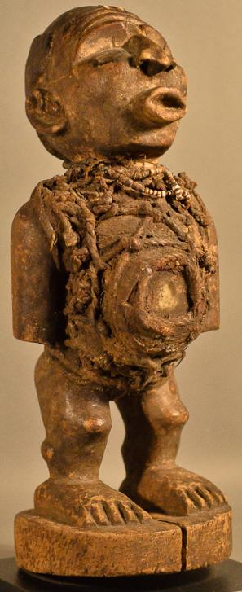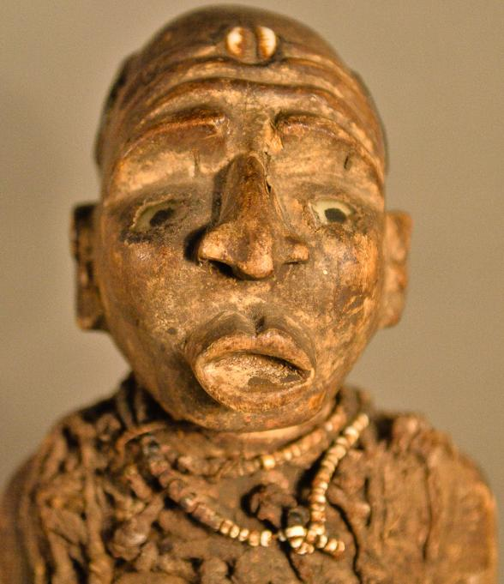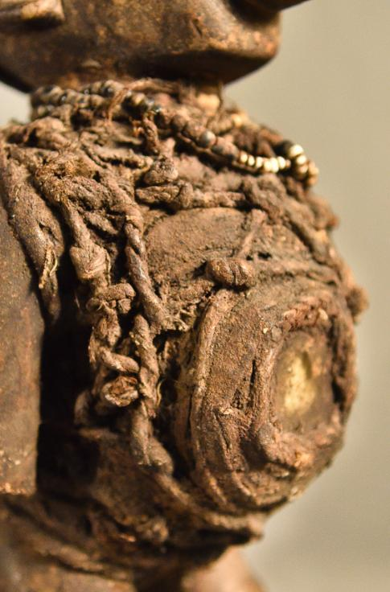

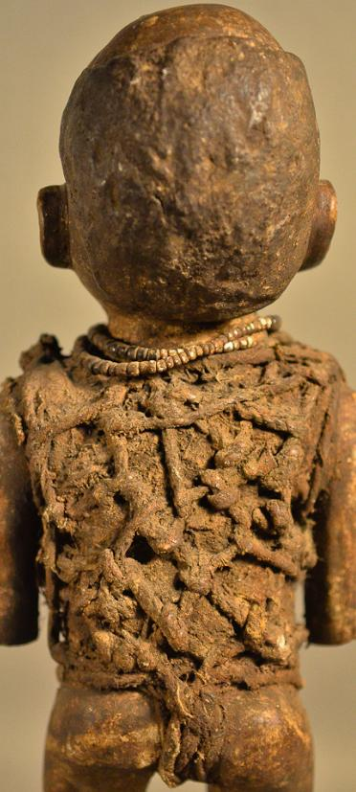



* 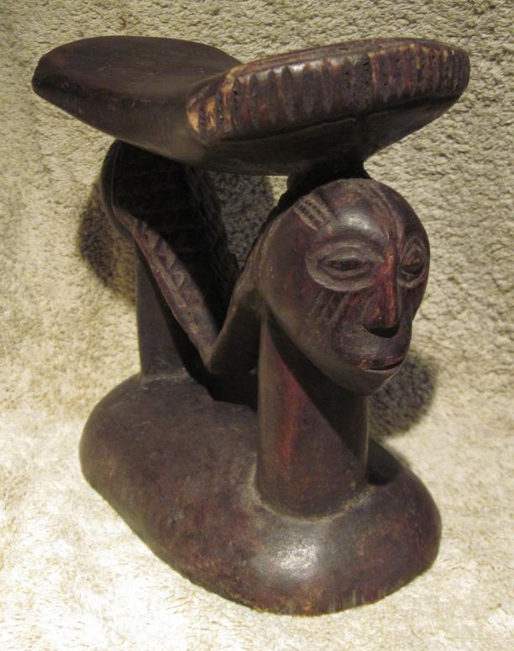 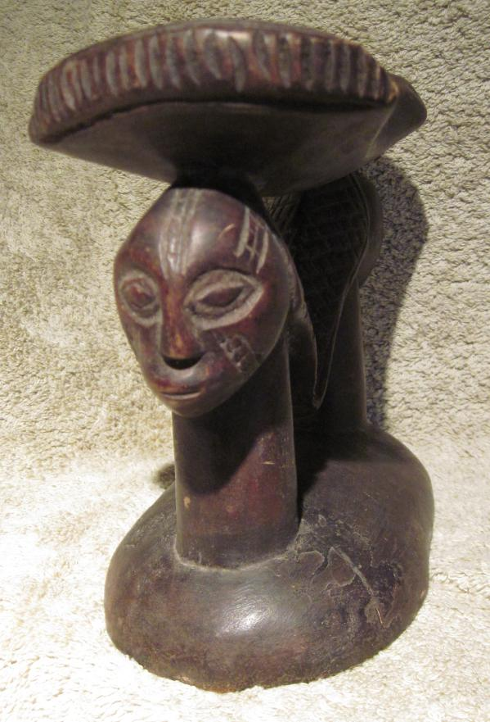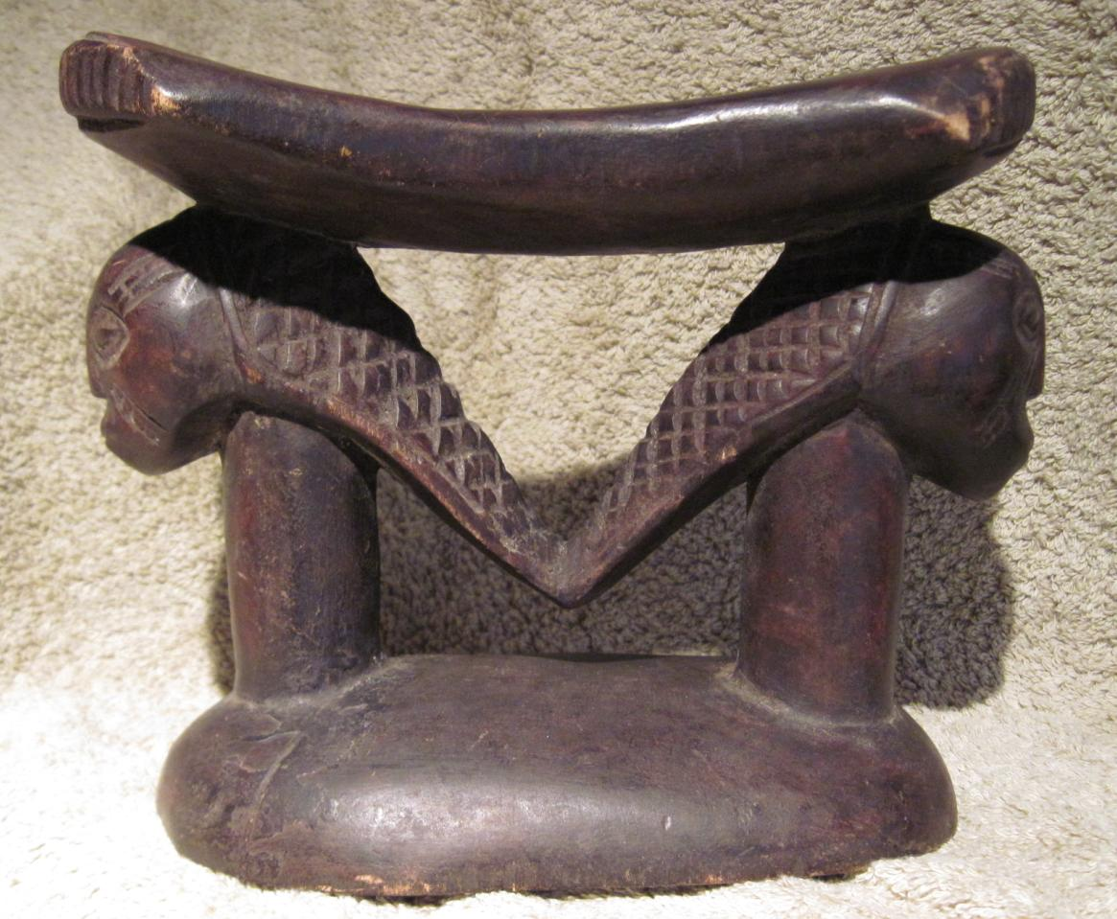

Dis-Afr-Ghana-Tchamba

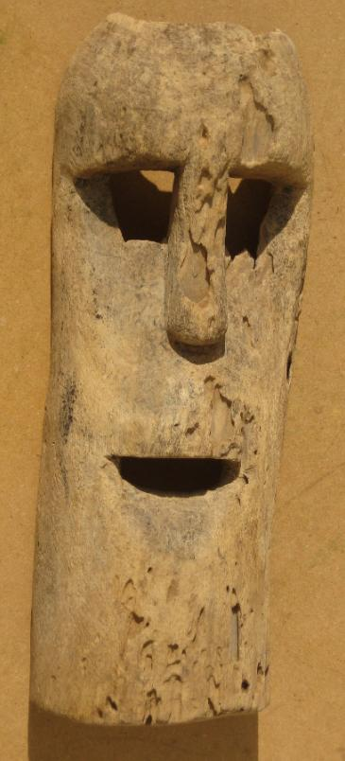 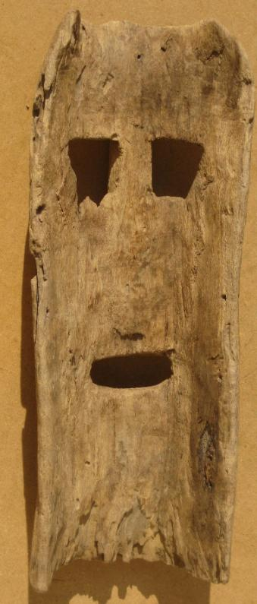 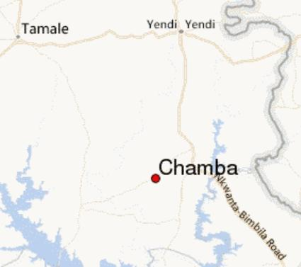

A nineteenth-century, intact wooden mask from the Tchamba indigenous people of northern Ghana whose area was once as large as the Protectorate of the Northern Territories of the British colony of the Gold Coast at the beginning of the 20th Century. This mask was collected in Chamba, their remaining tribal village in northern Ghana. Due to the Dagomba tribal wars between the [Dagomba people](https://en.wikipedia.org/wiki/Dagomba_people) and the [Kokomba people](https://en.wikipedia.org/w/index.php?title=Kokomba_people&action=edit&redlink=1) in the aftermath of the [First World War](https://en.wikipedia.org/wiki/First_World_War), many Tchamba fled south to [Accra](https://en.wikipedia.org/wiki/Accra), and still others founded Tchamba in Northern Togo.

Light-to-medium density wood, with superficial insect damage. Two drill holes (one field repaired) on either side for raffia decoration or hold-strap.

14 inches tall by 5.4 inches wide. 1.1 lbs.

DIS-AFR-MASK- **SONGYE KIFWEBE MASK EARLY 20TH CENTURY**

**Country: Congo (D.R.C.)**

**People: Songye**

**Period: Early 20th Century**

**Material: Wood/Pigmentation**

**Dimensions: L x W x D (cm)**

**Weight: lb 7 oz (kg gm)**

**Description:**

**A large Songye Kifwebe mask.  The mask is a classic Kifwebe stylized mask with a sagittal crest,** **protruding eyes, nose and quadrangular mouth.  Incised lines throughout with black and white pigmentation.  Raffia holes at sides.**

Price:

US $3,750.00

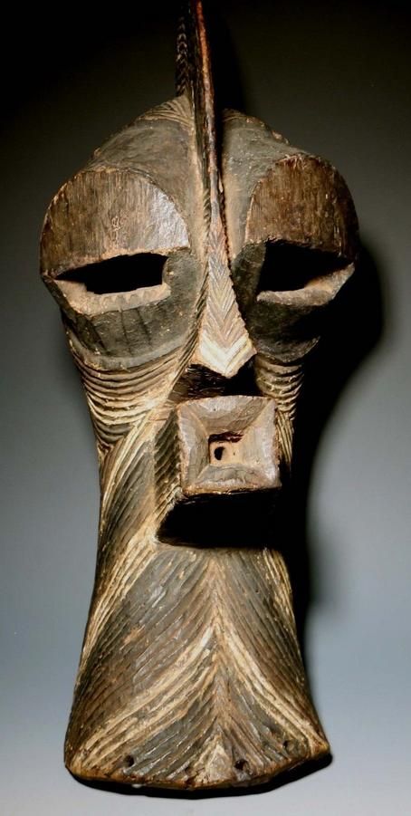

DIS-Afr-Benin-Trophy Head

A stunning Benin bronze trophy head, this has been made using the traditional lost wax method and very well done. On the inside of the head there is visible corrosion. The high neck collar represents coral beads, and the coral cap worn by Oba’s is present in fine detail. This piece was part of a very large old collection of African art from a deceased collector from Antwerp, Belgium.

* 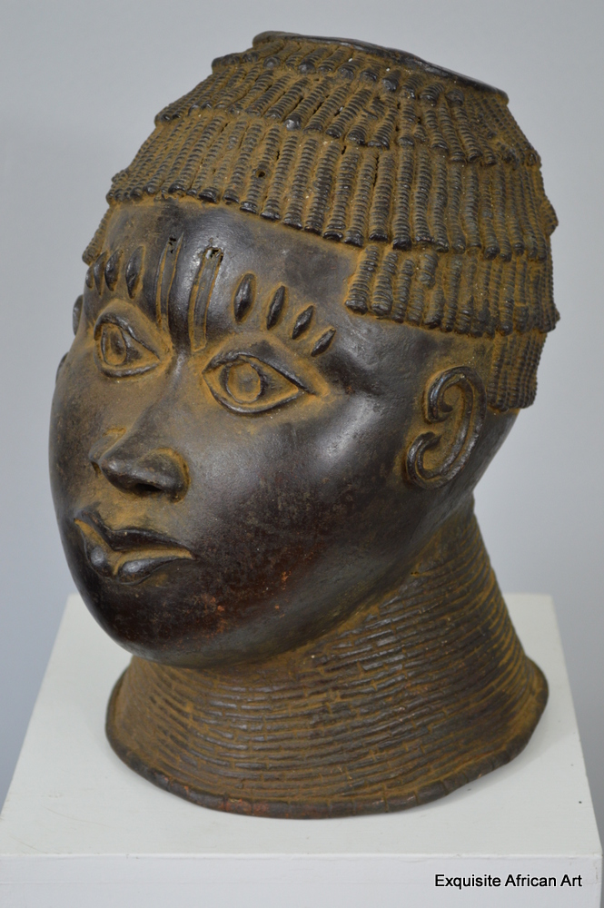
* Tribe: Benin
* Origin: Nigeria
* Approx Age: Early 20th Century
* Materials: Bronze
* Dimensions cm: 31 tall x 19 wide x 24 depth x 4.2kg
* Ref. Number: 0351

£1250.00

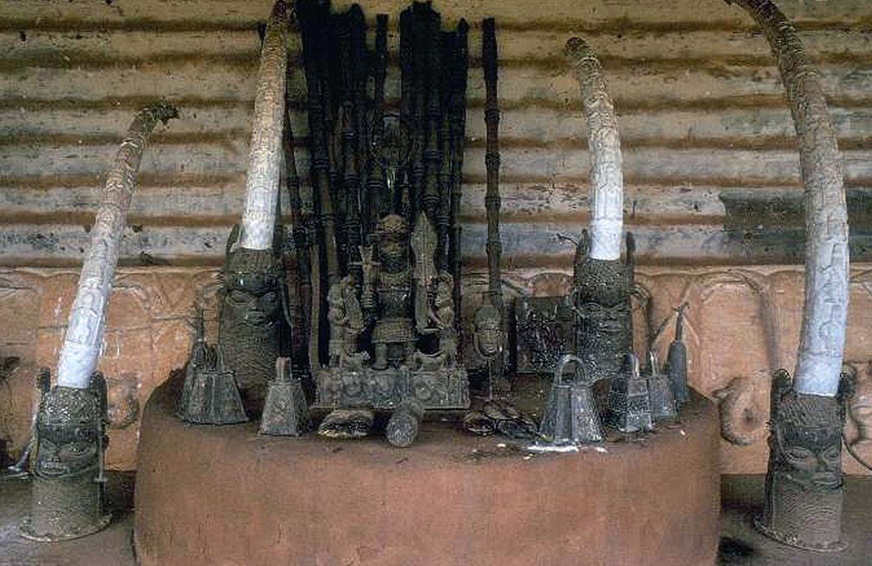 From http://exquisiteafricanart.com/wp-content/uploads/2015/03/Benin-Altar-of-Oba-Ovouramwen1-300x191.jpg

As in many African traditions of representation, Benin images always show a person in the prime of young adulthood, regardless of their true age and appearance. Contemporary informants in Benin City regard this as a “trophy” head of a foreign ruler, rather than a representation of an Oba. They recount that defeated recalcitrant foes would be decapitated and their heads cast in bronze to be placed on the shrine of the ancestors of the Benin Nation. Certainly it could never have carried a heavy tusk like the larger Oba heads. There is no doubt that the interpretation of these heads has been greatly confused by the publications of pictures taken of Benin in 1897, after the altars had been disturbed.

“The Art Of Benin” by Nigel Barly

The vast majority of Benin’s artworks are designed to honour the achievements and/or memory of the Obas, the divine rulers of the Benin polities. Until the late 19th century, the Benin centres were a ruling power in Nigeria, dominating trade routes and amassing enormous wealth as the military and economic leaders of their ancient empire. This changed with the appearance of the British forces, which coveted the wealth of the royal palaces and found a series of excuses to mount a punitive expedition against the Oba’s forces in 1897. It was only at this point, the moment of its destruction, that the true achievements of the Benin polities became apparent to western scholars.

Stylistically, the Benin heads follow certain conventions through time, but as metal does not lend itself to radiometric testing it is hard to be sure as to precise dates. The typology currently in acceptance is likely to be overturned as others have been.

The piece in question is a magnificently formed and executed casting of a youthful, well-nourished male. The hair is in fact a beaded crown that is cut to the temples across the forehead, then dips once to the level of the ears. It is comprised of five bands of overlapping beadwork in the rear, and three bands at the front. The apex of the head is missing, to allow the introduction of a tusk. The forehead is prominent, acting as a shelf over the eyes, and decorated with a central double scar indentation and four “pellets” arranged in two groups of two. The eyes are unobscured, large pointed ovals distinct peripheral rims and distinct irises that were originally inlaid with iron. At the lateral apex of each they have a trefoil linear design picked out in relief. The nose is long and elegant, with a broad trilobate end. The lips are fine, yet full and well-formed with a naturalistic fovea above the top lip. The rounded chin hints at the prosperity that the dead Oba doubtless enjoyed through his life. The ears are portrayed as delicate swirls in a faintly molluscan format, and the entire head sits upon a series of twenty one fine, sectorial neck rings that do not extend up onto the face.

The head summons up the traditional issue of the relationship between the Benin and Yoruba polities, for the elongated triple “whiskers” joining the lateral aspects of the mouth to the ears are not often found on Benin pieces. While the Oba has traditionally been associated with the leopard, this was more likely to be expressed as zoomorphic designs and artefacts rather than feline lycanthropy such as this. The Yoruba, however, did use this motif. This is therefore a fascinating object from historical, social and artistic perspectives. The importance of the Benin polity to the development of African and even world art cannot be overestimated. This piece would take pride of place in any serious collection of African art.

